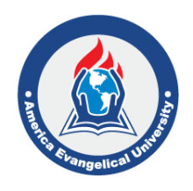
졸업 심사 신청서
(Application for Graduation)
America Evangelical University

학생이름(Name)
학위과정(Program)
입학년도(Admission Year)
Date of Bible Comprehensive Exam | (신학학사/목회학석사 학생들만 해당됩니다)
Tuition Balance | Yes ________ No ____________
Expected Graduation | Spring ____ Summer _____ Fall ____ Winter _____Year ________

Applicant Signature Date

Office Only

CFO |  | Dean of Academics

America Evangelical University
1204 W 163rd St, Gardena, CA 90247
Tel)323-643-0301
www.aeu.edu

